**AGILE METHODOLOGY**

Agile Methodology is a project management framework that divides projects into smaller, manageable units called sprints. It follows an iterative and incremental approach, where development occurs in short cycles, allowing teams to deliver functional components of a project regularly.

After each sprint, teams conduct retrospectives to evaluate their performance and identify areas for improvement. This continuous feedback loop helps teams refine their processes and enhance product quality over time.

Unlike traditional models such as the Waterfall methodology, Agile promotes flexibility and quick adaptation to evolving requirements. This enables teams to continuously deliver value to the customer throughout the entire project lifecycle, rather than waiting until the end.

**Top of Form**

**Bottom of Form**

**The four main values of Agile project management**:

1. **Individuals and interactions over processes and tools**  
   → Focus on teamwork and collaboration rather than strictly following tools or procedures.
2. **Working software over comprehensive documentation**  
   → Deliver functional software quickly; documentation is secondary.
3. **Customer collaboration over contract negotiation**  
   → Engage customers throughout the process for better results, rather than relying only on initial agreements.
4. **Responding to change over following a plan**  
   → Be flexible and adapt to change instead of rigidly sticking to a fixed plan.Bottom of Form

**Popular Agile Frameworks:**

1. **Scrum** – Focuses on fixed-length iterations (sprints), roles like Scrum Master and Product Owner, and regular ceremonies like daily stand-ups.
2. **Kanban** – Visualizes work on a board to improve flow and reduce bottlenecks.
3. **Extreme Programming (XP)** – Emphasizes technical practices like test-driven development, pair programming.
4. **Lean** – Focuses on eliminating waste and delivering faster.
5. **SAFe (Scaled Agile Framework)** – Helps apply Agile practices at enterprise scale.

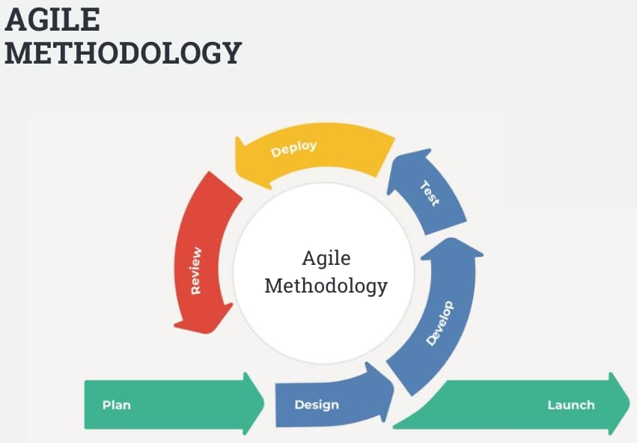

**Key Components of Agile Projects**

* Product Backlog: List of features or requirements maintained by the Product Owner.
* Sprint: A short iteration cycle (usually 2 weeks) where a subset of features is developed and tested.
* Daily Stand-up: A quick meeting where team members share progress, plans, and blockers.
* User Stories: Brief, user-centered feature descriptions (e.g., "As a user, I want to...").
* Retrospective: A meeting at the end of each sprint to review what went well and what could improve.

**Key Principles of Agile:**

1. Customer satisfaction through early and continuous delivery.
2. Welcome changing requirements, even late in development.
3. Deliver working software frequently, from weeks to months.
4. Business and developers must work together daily.
5. Support motivated individuals and trust them to get the job done.
6. Face-to-face communication is the most effective way to share information.

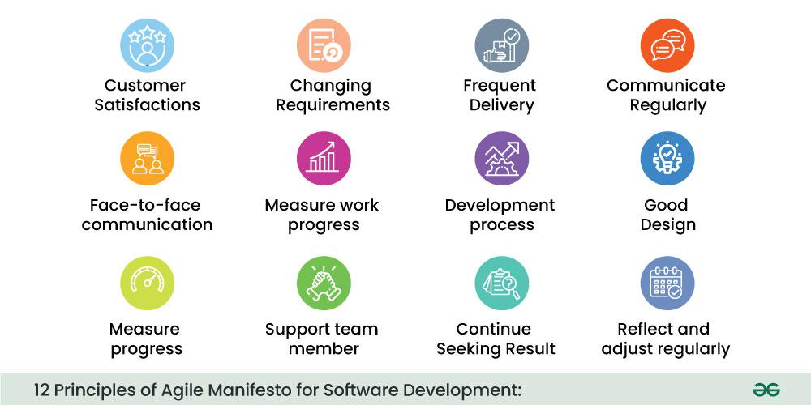

1. Working software is the primary measure of progress.
2. Maintain a sustainable pace of work.
3. Focus on technical excellence and good design.
4. Keep things simple – do only what is necessary.
5. Teams should be self-organizing for the best results.
6. Reflect regularly and adjust to improve efficiency.

**Benefits of Agile:**

* Faster delivery of working software
* Better collaboration and transparency
* Early identification and handling of issues
* Greater flexibility to adapt to change
* Increased customer satisfaction

Agile Methodology offers a powerful, flexible, and human-centered approach to managing projects. By focusing on collaboration, adaptability, and continuous delivery, Agile enables teams to produce high-quality software that meets user needs—even in fast-changing environments.